Comprehensive Creative Technologies Project: Emissions Tracking: How an app can help lessen emissions in daily lifestyles.

**Author Name**[ryan2.brereton@live.uwe.ac.uk](mailto:ryan2.brereton@live.uwe.ac.uk)  
Supervisor: Mary Jackson

Department of Computer Science and Creative Technology

University of the West of England  
Coldharbour Lane  
Bristol BS16 1QY

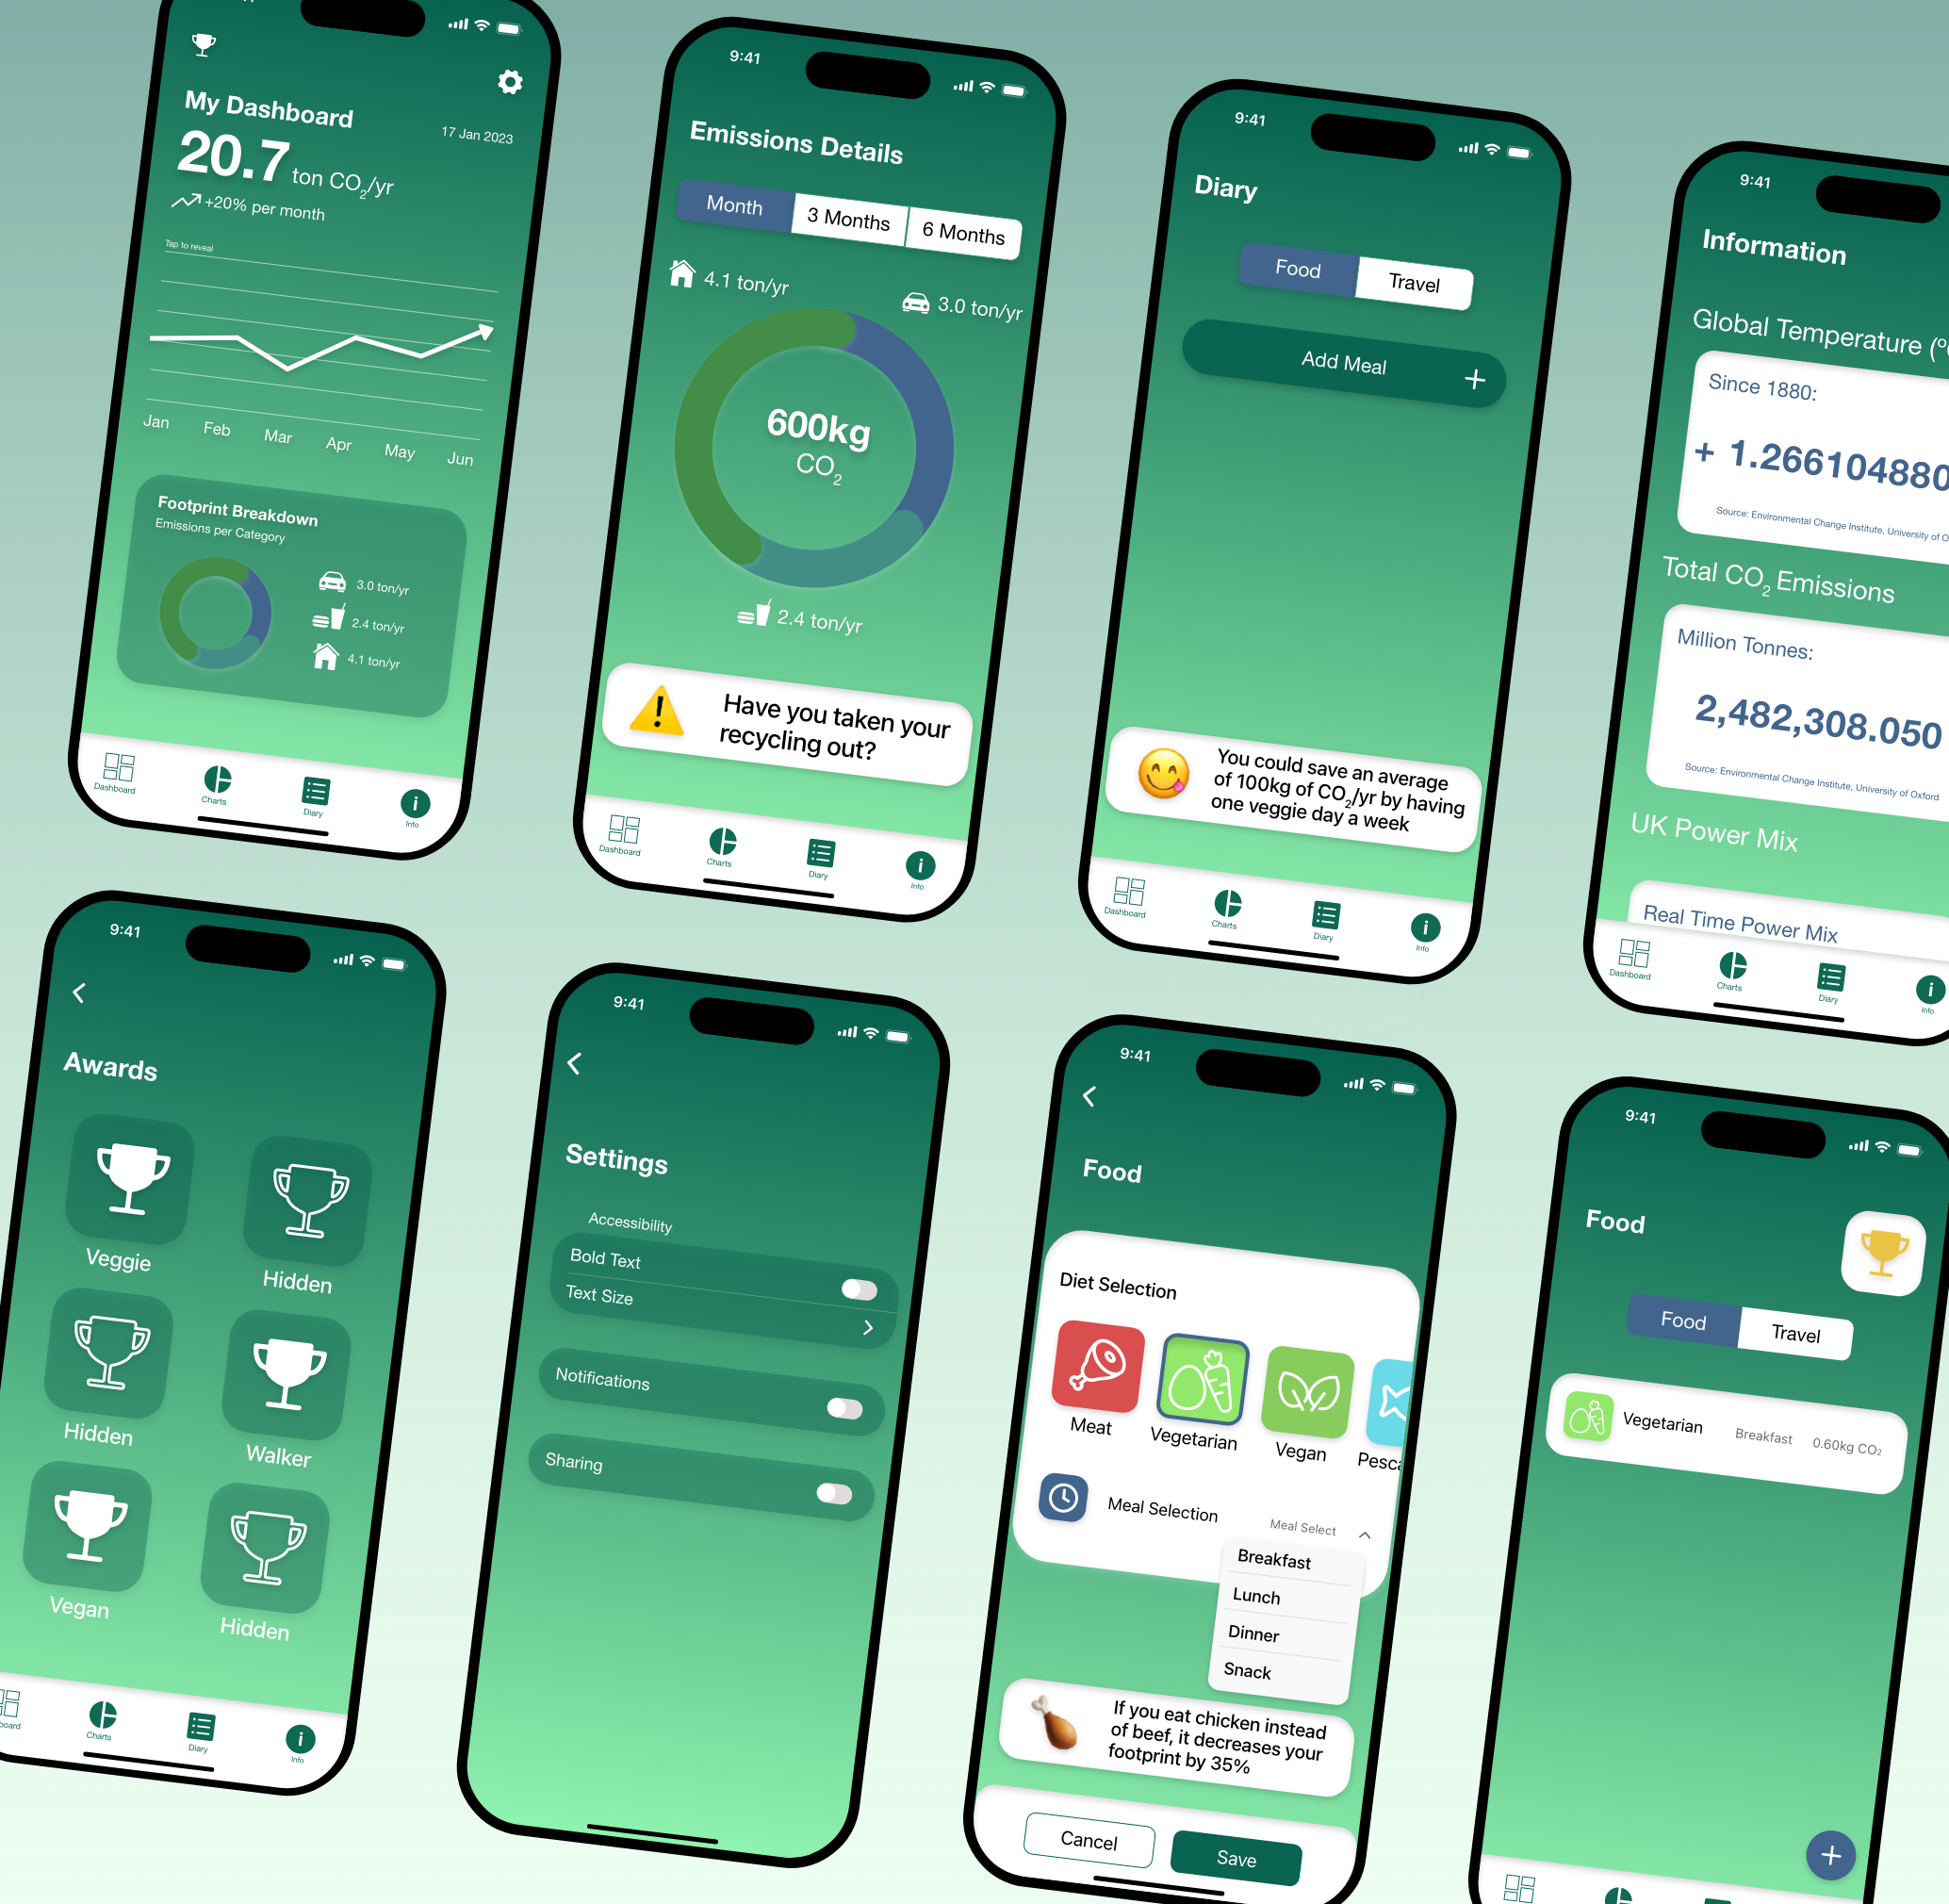

**Abstract**

Climate change is a critically discussed topic. It is talked about in all kinds of media forms including the internet, social media, newspapers, news outlets and books. A specific form of media that has jumped onto the scene is mobile apps. With the Paris agreement target of 1.5ºC global average temperature increase looking less likely, and some scientists now taking a more pessimistic view that it is impossible to reach 2.5ºC or even up to 3ºC is now to be the new target, the consensus has become now to give up. However, there is research to suggest that there is hope and that people should not give up and should, now more than ever, strive to introduce small changes to their habits and lifestyles. This project is about the research, design and development of a mobile app prototype. The app aims to convey information about climate change, allow users to track their daily lifestyle habits and to associate with users and provide positive hints to encourage habit changes. Investigating more into this project enlightened the fact that the hope is not lost despite the hinderances that arise. There is a drive within people to do better and to make a change. With more people onboard, millions of tonnes of emissions can be spared and as technology progresses climate change can be mitigated and, with enough collected effort, even resolved for good.

**Keywords**: Carbon Dioxide, Emissions, Psychological, Prototype

**Brief biography**

My name is Ryan. I am a digtial media student. This research project is about using an app on the phone to help convince the user to make small chnages to their lifestyle to help offset emissions. The project is researched and started from scratch. A project management approach has been taken as that is the field that I would like to step into after graduation. This project has helped me understand more about hwo to dictate a project and how to manage the time and work that needs to go into completing small tasks in order to finish the whole project.

Portfolio: <https://ryanbrereton.wordpress.com>

**How to access the project**

Below, are ways to access different sections of the project. There is a video demonstrating the prototype, an explainer video describing the choices and research behind the prototype and a repository with all files, videos and images included in this project.

Prototype Demo: <https://youtu.be/b7e34NsEo8s>

Presentation Video: <https://youtu.be/sqQ5NIsWuNg>

Files: <https://github.com/Womit/CCTP-Project-Files.git>

**1. Introduction**

With climate disasters being witnessed across the world and seasons becoming more extreme, the individual is always being told that they could do more to help tackle it. This project outlines how people can reduce their carbon footprint.

To help people gain more awareness about reducing their carbon footprint, a brilliant way to expose this information to the public is to create an app. This app would provide information and allow the user to track their daily routine and calculate their Carbon Dioxide (CO2) emissions. The app would provide suggestions to the user as to how they could reduce their emissions by, for example, suggesting certain food alternatives or an alternative mode of transport.

Finally, the app would have a utility that shows a live temperature rise since 1980 and a UK power mix. This would be a temperature gauge and a chart showing different power sources that the UK is using, in real time, in percentage points.

**Deliverables:**

* App prototype
* Clean and consistent UI that follows an environmental aesthetic.
* The ability for the user to log their daily routine.
* A feature that provides the user suggestions to lower emission.
* A page that provides brief information and the live temperature and UK power mix trackers.

**2. Literature review**

A series of articles and videos focusing on various topics based on this project have been read/watched. All articles have been searched for using the UWE Library and Google Scholar. The videos watched were from YouTube however, they were created by reputable creators that gained verification from experts or are already experts within their field. Upon encountering the research sources a check was conducted focusing on the currency of the source, the relevance, the accuracy and the purpose of the source. This ensured that the research is suitable for the project and there is not any information that is now out of date. The only time older articles were used was to refer to older research as an argument or counter argument for more current research.

The first load of research focused on human behaviours. This included habits, diet and it included human behavioural change. Several articles were found and read to gain a good idea about how humans behave and how humans get into habits. The articles research were recent articles that provided a lot of interesting information about how humans like to settle into a routine and how that they find it hard to break habits (Linder et al. 2021). The same applies to diet too. In a video about whether meat is bad or not (Kurzgesagt, 2021), the conclusion was drawn that whilst meat does affect the environment, if people just limit their consumption, then the impact on the climate could decrease by a substantial amount.

The next section of research that was conducted was the power of the media and misinformation on social media. A series of articles were found that were about the power of the media and the dangers of social media and misinformation. Damsbo-Svendsen (2022), described how the media has the power to influence decision makers and to spread the word about climate change. Moreover, Park and Rim (2019), write about social media and how people are easily able to spread hoaxes online and anyone could read them.

The final section of research is more of a lighter note to research about. Two videos were watched to research about there is still hope for humanity to mitigate climate change and that the climate wo not change too much in the future. Two videos, one by Kurzgesagt (2022) and Dr Simon Clark (2022), both strategically discuss how there is still hope for humans to slow down and even reverse climate change. Although not being able to completely reverse climate change, the steps taken already has ensured that humans have managed to dodge the worst possible scenario that scientists had predicted previously.

**3. Research questions**

1. How to convey the right information to people and have them understand it using the media and technology?
2. Why changing habits and change on its own is hard for some people to accept?
3. Is there any hope and motivation for people introduce lifestyle changes or has humanity gone passed the point of no return?
4. What features can a carbon tracking app have to help people lessen their greenhouse gas emissions?

**4. Research methods**

For all questions above, secondary research was conducted. Articles were found on both google scholar and UWE Library. Due to this project being an adaptation and reinvention of how a carbon tracker app can help change people’s habits and increase their CO2 management. Certain human traits needed to be researched and the use of articles was perfect for that. A lot of research has been conducted already on people about habits, social media and information and how to get people to change their habits this means that a lot can be learned about these three key areas and all of which are questions that are looking to be answered during this project. When looking for habits that humans hold, papers not just about technology and design but lifestyle habits were read. This provided a wider range of knowledge as the project covers both design technology and a lifestyle matter. The same can be said when researching for articles about information sharing and whether social media and the news have an impact on that. Misinformation is talked about a lot in the modern day. Research conducted on this topic was carefully thought out to ensure that any biases against social media, social media can be a great tool to express the right message if done correctly and the right person conveys the message, was expressed to a minimum to allow for all arguments to be conducted and conclusions drawn from content not opinion. This turned to be less of a worry because academic papers will take a neutral standpoint and draw conclusions based on findings and scientific facts.

There are already a lot of carbon tracking apps on the market so conducting a competitor sharing research chart to study their differences and conjure up a list of standout features that apps have or features that they are missing to find a happy medium to create an app that covers as many bases as possible. Moreover, because there is already a vast number of carbon tracking apps on the market, a decision was made to not use primary user research. Instead, just the use of competitor research and identifying strengths and flaws of current live apps.

**5. Ethical and professional principles**

No human participants will be involved researching this project so there are ethical concerns from that viewpoint. However, when designing the app there could be some ethical issues that may affect certain people.

The app is designed to help people change their lifestyle and habits when it comes to dieting and changing their lifestyles in general. For example, if the app is trying to get people to change their diets from a meat-eating standpoint, an example being changing from eating beef to chicken, this could impact some people with religious beliefs. Some religions have restrictions on eating certain foods and meats so telling them to change the way they eat could conflict with their beliefs about what they can and cannot eat.

Also, the app advocates change to habits in general lifestyle. This includes changing how people travel and how people manage their waste and energy usage. However, some people rely heavily on current means of transport/energy usage as they have accessibility or health reasons to. Some people may only be able to travel by car because they cannot walk or cycle too far. Moreover, some people may need to use a machine for their health which requires constant use of energy so asking for them to change their lifestyle could cause some difficulties for that kind of demographic group.

**6. Research findings**

With climate change being one of the main topics of concern in the world today, it is assumed that people are accustomed to changing their lifestyles as more people are starting to realise the impact daily lives can have on climate change (Hoffman et al. 2022). However, as Hoffman, Lasarov and Reimers (2022) elates, consumers are often unfamiliar about their carbon footprint. This demonstrates how important apps can be for people to use, to help them understand that everyday tasks can contribute a lot to their carbon footprint.

Not everyone in the world has equal knowledge to climate change due to each country having a different curriculum (Rousell and Cutter-Mackensie-Knowels, 2020).

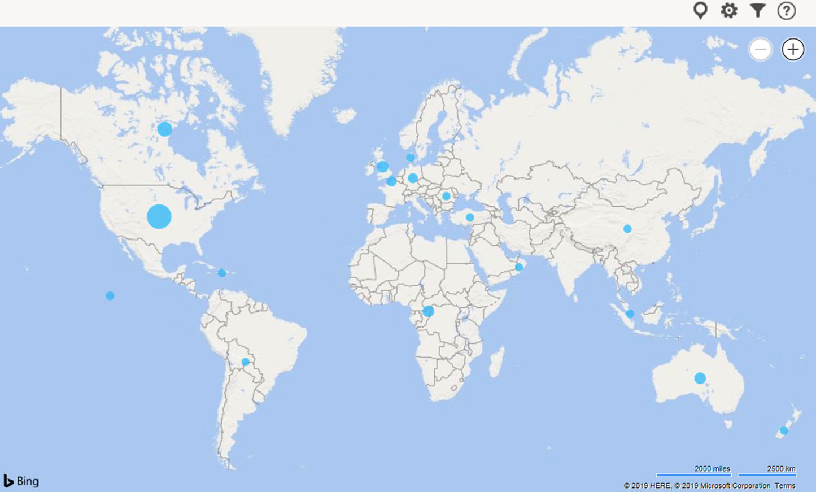

**Fig 1.** Global map to show climate change education density (Rousell and Cutter-Mackenzie-Knowels, 2020)

Climate change is taught primarily taught in the west with North America and Western Europe having the most climate change education density. It demonstrates the divide between the western world’s education in comparison to superpowers like China and Russia. Producing an app worldwide will ensure that as many people around the world as possible can learn about climate change and about how people can soften the impact if everyone was to join in as a collective.

Having a better education can help unmask any misconceptions about climate change. As Hannula (2022) alludes to, undergraduates in the United States, plus others around the world, hold many misconceptions about climate change. A way to freely access the right information on a handheld device can help people read the correct information about climate change.

Behavioural research was the researched and specifically looking at people needing to learn how to adhere to change and they need to start changing their diets. Humans, in their daily lives, develop habits through repeating actions. However, despite having the intrinsic motivation, one is likely to manifest to change one’s habits to pro-environmental ones. (Linder et al. 2022) Alternatively, the forced behaviour change might require more time for the individual to settle into the newly adopted behaviour (Isbanner et al. 2021). People find themselves reluctant to change. This is especially evident for when one is to change their habits. People tend to need a lot more convincing or take a lot more time to adhere to change their habits. This accounts for both forced change and voluntary change as the original habit, which would seem like a routine, would be the hardest to change without incentive.

Looking at social research, the media has found a way to dictate the people’s opinions on climate change. As Damsbo-Svendsen (2022), alludes to in his paper, with media coverage being so huge, it has the power to focus on a political issue and use the coverage to shift decision maker’s opinions or even shift their original decision to force them into a U-turn. For something that is talked about everywhere, read everywhere and even watched everywhere, it is no surprise when it is regarded as a highly powerful entity in countries. Specifically democratic companies as they advocate for free speech and free open access to media. However, due to the media holding this power, it has a heavy influence on major topics, like climate change. With climate change, there comes policies and when there is policies to discuss the media will get access to the stories and politicians talking about their policies. However, if there is any form of controversy, there is a high chance that, due to the power that the media and the people’s voice can have, the policy could get revised or even reversed and scrapped.

There is every chance, and a high one at that, that humans will get out of this climate disaster that is currently underway and that humanity will be able to help resolve climate change and put an end to emissions.

In a recent video by Kurzgesagt (2022), they explain about how right now, human actions are the direct and leading cause of climate change. Despite conceding that the 1.5ºC target from the Paris Agreement will not be met, experts are still hopeful that climate change can be slowed and eventually stopped. Before this, scientists insisted that a 4ºC+ climate was going to be Earth’s future, but the tone has shifted dramatically. The group refer to renewable power is now cheaper than ever before and that there are more electric cars on the roads too. Old fashioned energy production, such as the burning of coal, has been plateauing in countries like India and decreasing dramatically in others like the UK.

With the target of 1.5ºC being dubbed as a ludicrous goal and experts originally saying that there was little to no hope for humanity, it caused countries to give up on rescuing the world straight away. Another factor that deterred countries from sticking to their commitments was the price of energy. Coal was the cheapest source of energy in the mid-late 1990s and even in the beginning of the 21st century. However, now coal has become more expensive than renewable energy, which has matured and developed to become a reliable source of energy. With this shift in trend, it gives humanity the hope it needs to wane itself off oil and gas and to move over to the use of renewable energy. Thus, contributing less to the world’s overall carbon 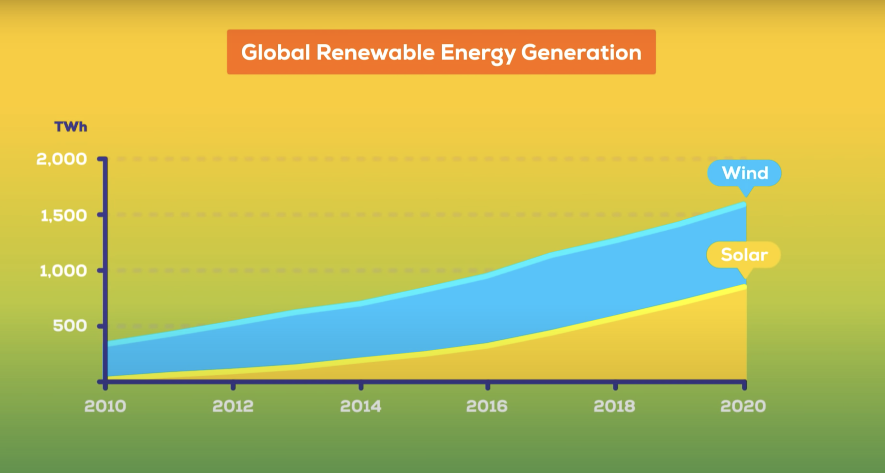footprint.

**Fig 2.** Screenshot displaying the rise of solar and wind energy generation (Kurzgesagt 2022)

The graph above, taken from a Kurzgesagt video, displays the energy generation changes and how renewables like solar and wind have become much more popular and now generate more energy than ever before as of 2020.

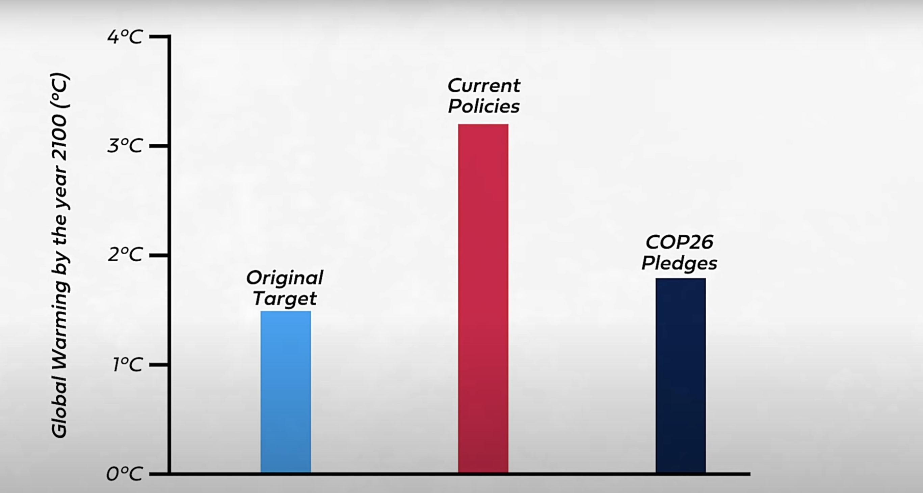

***Fig 3.*** Screenshot displaying the 1.5ºC target not being met with current policies (Clark 2022)

The chart above, taken from Dr Clark’s video (2022), referred in literature review, shows the viewer how current global policies are not sufficient to meet the Paris agreement’s 1.5ºC target. However, it shows that with the current COP26 pledges, and providing world leaders stick to their pledges, the overall warming of the globe would only go up to 2ºC. This is a symbol that humans can and are doing something to help slow down and prevent a disaster.

**7. Practice**

Market competition is the first issue that needed to be considered. An evaluation needed to be created as to how this application could be different from all others on the app market now. Competitor research proved to be essential as each app had a feature that could either be used or a feature that was missing and could be utilised. The use of features like an information page and a dashboard giving detailed insights and data about the user’s emissions was only used by a handful of competitors makes them an important feature to handle. Moreover, the ability to save a diary and not have to log in is always a celebrated feature to possess as any user can just hypothetically install the app and just use it straight away. Furthermore, inspiration taken from Apple’s activity and health apps, the addition of rewards and influential messages are features that were considered and eventually used within the app’s prototype. These give psychological aspect to the app. The aim is to help the user stay motivated and add gamification to the app. Human nature is to ultimately grow to change as stated in the research above, change is not always easy for people and asking people to change their lifestyles (Linder et al. 2021). Therefore, adding a form of gamification to the app enables the user to compete against themselves.

A series of methods to round up the key takes from the competitor analysis were taken and the decision to create a chart analysing the strengths, weaknesses, opportunities and threats (SWOT Analysis) was made. This proved to be the most effective technique as it did not need to be too detailed, however, it needed to be realistic, critical and evaluative. Alongside the competitor research and research from articles and videos, all from credible sources, ideas, features and potential risks that could arise by creating the app could be drawn up into the SWOT Analysis.

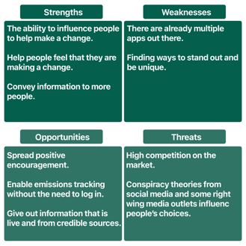

***Fig 4.*** Screenshot of SWOT Analysis created during research period of project.

There was not a need to perform a wide range of user experience research as the app market already has a lot of material to research. Additionally, as this prototype is an adaptation of a carbon tracking app with the focus on psychological aspects to help positively influence the user to lower their personal emissions by making small changes to their lifestyle and habits, this made the use of primary interviews feel unnecessary. There was no intention to fundamentally change the blueprint of the carbon tracking app.

In order to figure out how to effectively utilise psychological principles, a target demographic had to have been chosen. The decision for users with opposite demographics was made. This provided a wide scope of users and scenarios that the app could be used in. Each persona was created based on the research conducted already; a younger person with the desire to make a change to improve emissions. They have a slight understanding about the damage humans are using on the planet but want to learn more and do more to help mitigate the effects. The second persona is someone who does not have a desire to change and portrays themselves as more of a sceptic about the climate crisis. They do not have any concern and they tend to try and shut out what the media and others are saying about the climate crisis. Their only motivation is an external factor such as a younger family member trying to open their eyes to the issue at hand. Engrossing in these two helps gain an understanding of people’s behaviours on both sides of the spectrum. The reason for the two opposite persona is the result of a study by John Burn-Murdoch at the Financial Times (2022). Although the study concluded that there is a shift in the traditional tide of the older generation, in the UK, voting for more right-wing parties, who do not usually or have their climate goals on the backfoot, manifest their desire to help with the climate crisis, previously, the trend was the contrary. This implied that the younger generation aligned to the left, who express concern for the climate crisis. However, according to research conducted by TLDR News EU (2023), this trend has only been seen in English speaking countries. In Europe, younger people are leaning more towards the right wing with environmental policies falling further down the list of priority. Therefore, justifying the reasoning that the persona should be opposites.

(See appendix D for the user persona and journeys).

Every app, whether it is a prototype or being developed, needs an app logo and a name. It was fitting that a name and a logo was created. The precedent was set to ensure that the prototype was made to be unique in comparison to other apps on the market and this helped to and to the uniqueness of the prototype. The name of the app is called Track My Footprint.



***Fig 5.*** Export of logo for prototype; Track My Footprint.

Application visuals was paramount to the prototype design, however, there is already a colour scheme that is uniform to all carbon tracking apps. Green, yellow and a tint of blue. Green was the decided colour scheme as it was the generic colour scheme that most of the competition already used. Despite wanting the app to be unique, the app also needed to be recognisable too. Using the green colour scheme felt paramount to use to achieve the app to be both recognisable to the user but also ensure that the user knew exactly what kind of app they could be downloading. This aligns well with the colour green being associated with nature and the environment due to chlorophyl being produced by plants and causing them to form a green colour.

With the design being underway, in user experience design (UX design), navigation is a key area of focus. Under normal circumstances, a navigation flow would be created to help the designer visualise how the user would journey through the app. However, with there being a vast pool of carbon tracking apps already on the market, they mostly follow the same navigation. Utilising what was learned from the competitor research, and creating a flow chart for visualisation (see appendix E), the navigation could follow the same route that the rest of the competition have taken. This contradicts the aim to create a unique prototype however, there was not a reason to change the structure as, based on the evidence seen from the competitor research, the technique must work well. However, when designing the app, despite showing a clear route for the user to take, the use of a navigation bar at the foot of the app allows the user the freedom to roam around the app in any order they like giving the user the free ability to move from the starting page straight to any page they desire.



***Fig 6.*** Example of navigation menu at the foot of the prototype.

When designing a prototype, applying consistent UX features is important as hypothetically, it will be carbon copied during development. Prototyping is a great way to demonstrate to users and developers how the app would work. Moreover, a prototype can show how visuals and elements can be used as a method of navigation and offer animation effects when interacted with. Prototyping can prove to be very versatile as there is a lot of intricate detailing that can be added even to features as minute as animations on buttons, for example, a like button animation when pressed on a social media app.

It is essential to have a strategy on how to complete it successfully and to a high standard. A series of project management techniques were used to manage workloads, time, scope and help to dissect the project accordingly to meet requirements and match the questions originally asked at the start of the project. When working on this project, agile methodology was utilised. This allowed the flexibility to break the project up into a series of ‘sprints’. Each sprint was used as a provisional goal to complete steps within the project. As a result, it allowed to keep the progression of the project organised and assisted with time management. Prior to the iteration of the prototype, a design technique known as Design Thinking 101 was followed to guide the project forward. The benefit of using this technique is that it solely focuses on design and development. The technique guides the designer/developer from the research and understanding phase, right to the testing phase. For time management, project log and a Gantt chart was created (see appendix A). The project log allowed for a brief plan to pan out all stages of the project with an arbitrary completion date. The dates could be changed accordingly. The Gantt chart was more detailed with the ability to check off completed tasks but shows tasks that were started late or not completed on time and therefore completed later. The Gantt chart allows the developer to stick to the scope.

Using the project management techniques, feedback was taken at stages during the design of the prototype. The feedback sessions were conducted as a scrum session with a supervisor. They provided constructive feedback on the prototype, logo and app name. The scrum sessions allowed for discussions about how the prototype can link with the research conducted prior. With the aim being the use of positive psychological techniques to encourage lifestyle habit changes, the supervisor helped outline areas where the research needed to tie into the prototype. This allowed improvement of the developments and gave encouragement to complete the project.

No project is completed without its issues that inevitably arise. There were a number of issues that came up during the project’s completion.

One consideration to think about was researching into the background of carbon tracking apps and how apps that are already on the market. This included research about climate change; about what are the leading contributing factors that people do in their everyday lifestyles. It also included social media and news outlet’s effects. This focused on how people gain their information and form their own opinions and beliefs. There was careful consideration as to how to effectively use the app to convey information. Consequently, the use of a live temperature, CO2 emission rate and UK power mix was used. The user can see exactly how much of an impact humanity is having on the planet and how the UK’s energy sector is performing compared to the global and national net zero goal. Moreover, a small amount of research on human psychology was needed. Since the goal of the app is to use positive motivation to encourage the user to keep going and to lower their footprint even more, a way of conveying this needed to be researched. Finally, a key research area was app features. Competitive research was extremely useful for this as most apps that are already out there all share the same fundamentals of a carbon tracking app. An effective way to collate all the data and information found was to take the fundamentals and then expand on them by using niche features that other apps use.

Uniqueness is the main focus. However, the aim is to also keep the app recognisable. Leading on from the research conducted prior, it was essential that the prototype was easily identifiable to users adding the obstacle of making the prototype unique in other ways. This is why the addition of a statistic section was used. This gave the user personal data that they can analyse based on their personal performance (See figure 7).

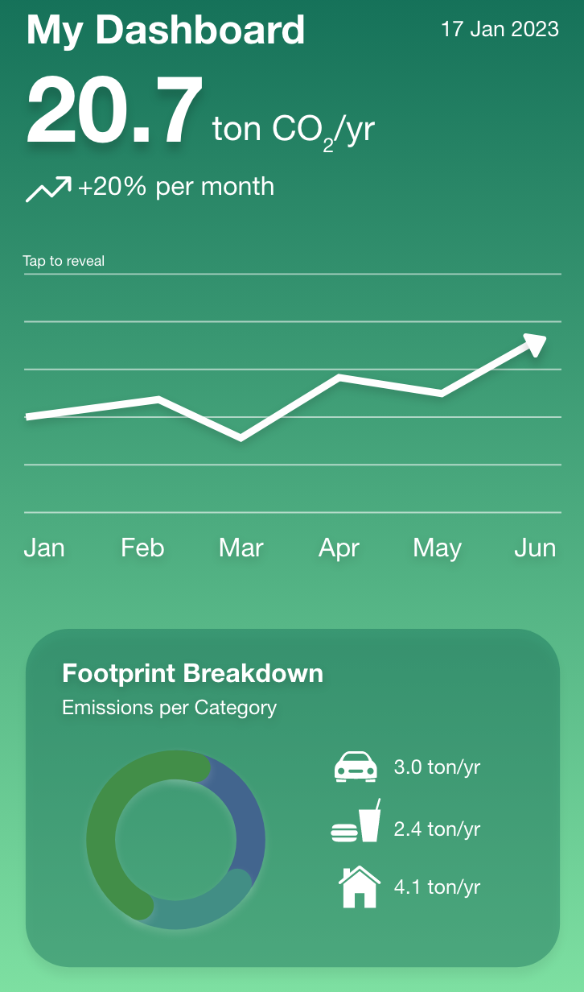

***Fig 7.*** Screenshot of dashboard in prototype demonstrating personal trend.

This proved to be an issue as originally, during the design phase, there was not too much of a consideration on this. With help from the supervisor, a technique was to use competitor’s apps from big developers like Apple. Apps created by Apple like the Health and Activity app have key features that both educate people and reward people to motivate them. The health app has small bitesize information paragraphs that allow users to learn about certain health biometrics such as blood oxygen. However, the Activity app utilises the use of rewards. These rewards are there to motivate people to keep exercising and moving to burn calories to close their ‘rings’. These are the sort of techniques that were to be sought to be adapted into the prototype in order to overcome the issue of creating a carbon tracking app that looked to possess unique features.

A common issue among many projects with this one being no different. Managing time was an issue that needed to be overcome to be able to effectively complete the project on time. With multiple projects ongoing simultaneously, the issue of time management was critical. Having the ability to effectively manage the time needed to not only complete this project, but the other projects undertaken was essential. However, doing so needed to take a lot of work and organisation. With project deadlines all being different it assisted the organisation of the when to work on what project. A main aim and subsequent goals were made to divide up the project to fit around the busy schedule. The aim was to complete the project, and then goals like, finish the project’s prototype were added with dates to complete them (see appendix B). This provided arbitrary deadlines to try and meet to stay on track.

Accompanying this, various project management techniques were applied. The techniques allowed for various focus changes and manipulation to suit outside factors that arose during the project’s course. The Gantt chart was used to help with the organisation of any changes that were made and the red boxes were kept to display the issues and the change of schedule. Keeping this on record allowed for the project to stay on track and to mitigate any lack of concentration or confusion as to where the project’s progression stood at the time. Issues like this arose frequently however, there was always a way to rectify the issue by staying organised and keep a log of where the project was heading.

Furthermore, with the log and Gantt chart, it prevented any lapse of concentration and ensured that more time than was needed was spent on certain areas of the project. It kept the project on track and the right amount of time was spent on all sections of the project. This helped with the quality.

Finally, keeping on top of time management assisted with motivation to complete the project. Motivation was a huge issue when completing the project as multiple simultaneous projects on the go at once proved to be overwhelming, although, managing time bolstered the motivation to proceed further with the project.

There were not many issues with any software used as past experience with using the software proved to assist with the development of the prototype. Had there been a lack of experience there may have been issues that could have arisen when in development.

**8. Discussion of outcomes**

Climate change has demonstrated polarisation within the world. There is a vast range of support amongst people who understand that it is an issue and that it needs to be solved quickly, but as Corner et al. (2012) alludes, people with preceding views or knowledge, tend to hold their own evidence that could prove to be misleading as it is presented in a misrepresented manner. This can prove to be damaging on people who could be sceptical or who want to learn more about climate change. The idea behind the app prototype is to try and convey information but to also make the user aware of their daily footprint.

The app needs to be able to express information for all users to understand. The information showed on the prototype only included the basic metrics that, hypothetically, everyone should be made aware of; global temperature rises and global emissions. These statistics would ideally be a live count based on a source, in this case Oxford University, that is reliable and that constantly keeps track. Finally, the decision was made to add in the power mapping mix to allow users to keep up to date with what energy sources are being used at that point in time. However, this had to be locked to just the UK as finding global data proved to be a challenge as not every country releases their national power mix and if they do, the data may not be reliable and accurate as some countries may want to suppress the amount of use from fossil fuels compared to others. Keeping the data set smaller and confined to the UK provided more accuracy and helps to keep the targeted demographic range to UK users.

The outcome of the prototype was based on the use of positive motivation to help people to change their habits and lifestyle. The aim was to get people to make small changes and let user know that every small change accumulates up to make a considerable difference especially when users, as a collective, carry the same goals and desires to change their habits. However, obtaining users who all possess the same aim to lower their emissions poses an issue as there are a vast number of potential users, each whom view climate change differently. Consequently, the prototype resorted to displaying short snaps of information with the intentional target of producing positive motivation to the user (See Figure 8).

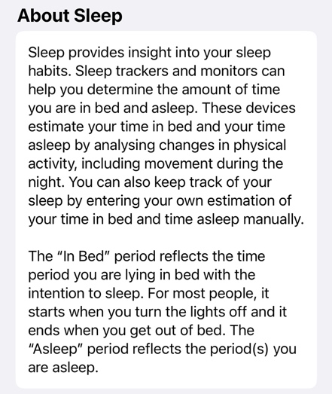

***Fig 8.*** Screenshot of information snippet from Apple’s Health app demonstrating learning within the app.

The question asked was whether, in the face of a decision, would people voluntarily change their habits or lifestyle to fit the current situation at hand. Hartig et al. (2001) reverts to negative environmental motivation is a direct result in a change with human activity. This is more out of fear or obligation and duty to change as external factors have also been affected such as habitat, relative experience, and noticeable change to personal lifestyle. However, the aim of the prototype is to prevent damaging factors and get users to want to make a change before inevitable environmental destruction has occurred.

Scaremongering is the opposite route to take for this project, in essence, positive motivation was needed to create a sense for change for the better. Competitor research, aforementioned, about how professional apps have achieved this was utilised to create ideas. Personal messages and an achievement system helped provide the positive motivation to help users change. The achievements system (see Figures 9 and 10) provided a form of gamification for the user to challenge themselves and other users alike. Competitiveness is in Human Nature as Cherki et al. describes in their research human competitiveness (2021). Although being a natural instinct for resources, the same concept can be applied to winning. Having this feature within the app therefore helps users apply more effort into changing their lifestyles to try and show friends or family that may also use the app or hold a morbid interest in wanting to help with the climate crisis.

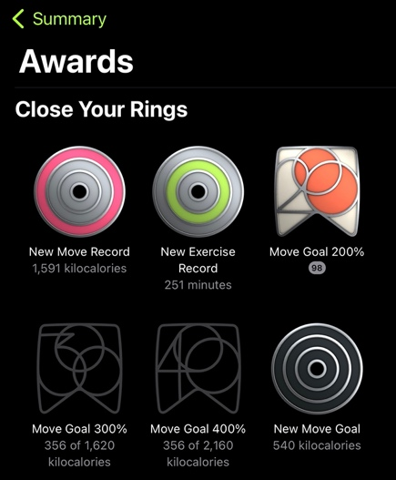

***Fig 9.*** Screenshot of Awards Page in Apple’s Activity app visualising gamification.

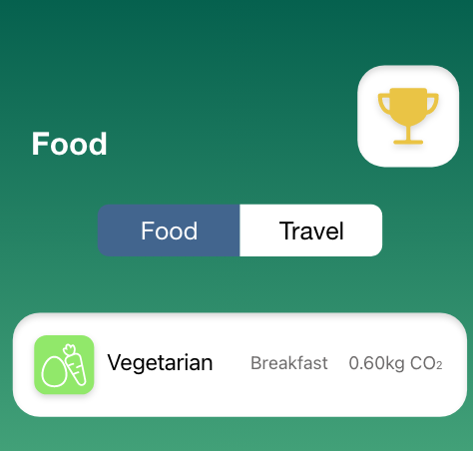

***Fig 10.*** Screenshot of information snippet from Apple’s Health app demonstrating learning within the app.

The features added to app were subtle but can prove to be effective. As the user journeys through there will be pages that have messages stating short facts about how people can improve their emissions by just making a small change within their diet or method of travel. These messages are not meant to induce a huge change just simple mini changes that the user can do quickly with little effort. The user would receive notification style pop ups (see figure 11) that do not cover the screen, so they still have an adequate user experience, and they have the ability to dismiss the message pop up too. The message would include subtle tips that try to entice the user to either carry on with what they are doing, or it may make the user aware or, alternatively, the message could advise the user on how a small change could, in the long run, help mitigate their emissions. Professional app researchers, designers and developers could draw some outside research about human behaviour to optimise the use of their apps.

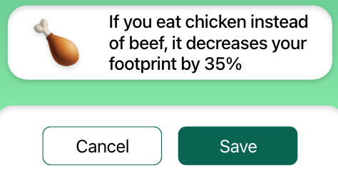

***Fig 11.*** Image of message prompt during usage of the app.

The outstanding issues faced when working on this project constituted of how to convey the same information, as the science already produced, in a manner that user can understand and process. Furthermore, another issue was how to create a prototype carbon tracking app that is both fundamentally the same, but also distinctive and stands out in the market when compared to other apps already out there.

Academic research assisted with the research on scientific information needed for the information section of the app. Using reliable sources ensured that the information would be accurate and current too. Competitor research enabled for app features exploration. Downloading and using various apps on the market allowed for the gathering of data and information about how each app looked, navigated and their own unique abilities that they have to offer. This allowed for decisions about how this project was to be conveyed and what unique features could be picked from current apps but also what features were not used by current apps or used in a different genre of apps and could be used within this prototype thus rectifying these specific issues that were faced when researching and ideating.

The use of the project management techniques, mentioned prior, proved to be extremely useful for this kind of project. An Agile methodology is one of the perfect methodologies to use as it allows for iteration and re-iteration. If the designer decides that a part of the project needs to be modified, then they have the full flexibility to adjust the design in the next sprint. With ideas and iterations being bounced around with peers and a supervisor, this technique was used multiple times and demonstrated the customisation that Agile offers to designers. In an Agile process there are a series of sprints. Each sprint is broken up into sections. These sections include planning, designing, deploying, testing, redeploying, and reviewing. Although not all of the processes were utilised as this project is only a prototype. Many were used such as the planning and design, then the deploying and review. These stages of the sprint were perfect for the project. It enabled changes and redesigns to be made quickly.

Another process was used during the project. Design Thinking 101 was practiced from a design standpoint. With the project being user experience and user interface orientated, it made sense to use this process. The process is divided into three categories and each category has 2 sub sections from empathise to implementation. The sections all lead into another and are suitable to be merged into an Agile methodology. The process was merged with agile and created into sprints. These sprints were complete with a starting ideation phase, design, and iteration phase, then finally, re-iteration, review and completion.

Moreover, a small amount of user testing was conducted amongst peers. Key points noted down were that they could definitely tell what the app was for and it consists of and that the user experience, overall, was adequate. However, there was mention that the message prompts at the foot of the app (see figure 11) did become tedious to deal with but they did find themselves reading them and learning a little bit more about their diets and their emissions.

Reiterating this project would prove to be more difficult with so many competitors on the market all covering the same fundamentals and then offering their own niche features that are custom to their app. However, the recommendations that can be made are based towards the project management process and research.

Firstly, more research can always be done prior to designing the prototype. Primary research was missing from this project as it did not seem to be as viable as competitor research when considering the vast range of existing apps on the market. However, primary research involving participants could prove to be effective in the future giving a second set of data and information which would be of value to developing a new app prototype that possess even more unique features and more effective ways of phycological motivation for users to experience.

Moreover, the use of project management techniques was found to be of value during the project with the Agile methodology being advantageous with its flexibility to adapt to changes in the project.

Finally, for time management the use of both a log and a Gantt chart should be considered and perhaps with even more techniques like something as simple as daily checklists that allow for the project to constantly flow and progress without any gaps between sessions leading to consistent work.

**9. Conclusion and recommendations**

Climate change has proven to be a hot topic for most people across the world. It dominates the internet on social media and news outlets on television. With it becoming more widespread, climate change has leaked into the app industry evident by the massive range of emission tracking apps on app stores.

With the vast amount of research performed on climate change and human behaviour, academic information was in abundance. However, suitable information had to be considered when translating it into ideas and features to be used wihtin the app prototype. This did prove to be a challenege when considering the competitor research completed showed that a lot of features had already been used by other app developers. However, learning about current political and social problems that arise everyday, paid dividends as it created opportunities that not many apps use.

Progressing this project further than it’s current form should be a tentative one. Devleoping it further for market release could be one step but due to the nature of the competiton, ideas need to be unique and distinctive. More research could be performed but focusing on a user viewpoint to consider user experiences like adding more sublt prompts and more rewards. Although there is an opportunity to be taken advantage of with how tehcnology and information is consumed in the modern day. A system to track and share progress with others or to share data across multiple devices would be a significant step forward and integration with wearbale devcies like smart watches.

Given due consideration, a completed advanced version of this project could be briefed as a competion and displayed at a conferences or exhibition and released onto the market elongating the message that climate change is real and is effecting everyone without immediate knowledge. The awareness about climate change has increased greatly. After completing this project, it is notable in that there is still ample opportunity and motiviation to show resiliance. It is encouraing to find out that people are willing, with the use of apps like this and the potential expansion of this medium of media onto all kinds of devices, to bond as one, and support what they believe is right based on scientific research.

**10. References**

Burn-Murdoch, John (2022) Millennials are shattering the oldest rule in politics. The Financial Times [online] 7 April. Available from: <https://www.ft.com/content/c361e372-769e-45cd-a063-f5c0a7767cf4>

Cherki, B.R.C., Winter, E.W., Mankuta, D.M. and Israel, S.I. (2021) Intranasal Oxytocin, Testosterone Reactivity, and Human Competitiveness. *Psychoneuroendocrinology* [online]. 132 (3), p. 1. [Accessed 19 April 2023].

Corner, A.C., Whitmarsh, L.W. and Xenias, D.X. (2012) Uncertainty, Scepticism and Attitudes Towards Climate Change: Biased Assimilation and Attitude Polarisation. *Climatic Chnage* [online]. 111, p. 466. [Accessed 18 April 2023].

Damsbo-svendsen, S.D.S. (2022) Mass Media Influence on the Rapid Rise of Climate Change. International Journal of Public Opinion Research [online]. 34, p. 1. [Accessed 16 October 2022].

Hannula, K.A.H. (2022) Education About Climate Change. *Journal of Geoscience Education* [online]., p. 1. [Accessed 18 October 2022].

Hartig, T.H., Kaiser, F.G.K. and Bowler, P.A.B. (2001) Psychological Restoration in Nature as a Positive Motivation For Ecological Behavior. *Environment and Behaviour* [online]. 33 (4), p. 591. [Accessed 19 April 2023].

Hoffmann, S.H., Lasarov, W.L., Reimers, H.R. and , (2022) Carbon Footprint Tracking Apps. What Drives Consumers’ Adoption Intention?. *Technology in Society* [online]. 69, pp. 1-2. [Accessed 17 October 2022].

Isbanner, S.I., Algie, J.A. and Reynolds, N.R. (2021) Spillover in the Context of Forced Behaviour Change: Observations From a Naturalistic Time- Series Study. Journal of Marketing Management [online]. 37 (10), p. 707. [Accessed 01 November 2022].

Linder, N.L., Giusti, M.G., Samuelson, K.S., Barthel, S.B. and , (2021) An Underexplored Research Agenda in Sustainability Science. Pro-environmental Habits [online]. 51, p. 546. [Accessed 01 November 2022].

Park, K.P. and Rim, H.R. (2019) Social Media Hoaxes, Political Ideology, and the Role of Issue Confidence. *Telematics and Informatics* [online]. 36, pp. 4-5. [Accessed 20 October 2022].

Rousell, D.R. and Cutter-Mackenzie-Knowles, A.C.M.K. (2019) A Systematic Review of Climate Change Education: Giving Children and Young People a ‘Voice’ and a ‘Hand’ in Redressing Climate Change. *Children's Geographies* [online]., pp. 194-195. [Accessed 17 October 2022].

Three Arguments to Avert Climate Dispair 2022 [online] Directed by Dr Simon Clark UK:. Youtube. Available from <https://www.youtube.com/watch?v=CqLukXm7nAc> [Accessed 8 December 2022].

We WILL Fix Climate Change 2022 [online] Directed by Kurzgesagt – In a Nutshell. Germany:. Youtube. Available from <https://www.youtube.com/watch?v=LxgMdjyw8uw&t=828s> [Accessed 8 December 2022].

Why Young Europeans are Further Right than Brits and Americans (2023) [online]. Directed by TDLR News EU. UK:. Youtube. Available from <https://www.youtube.com/watch?v=aMeGW2axyVM> [Accessed 11 April 2023]

**11. Bibliography**

Adobe (2023) *Adobe XD Learn & Support.* Available from:

<https://helpx.adobe.com/uk/support/xd.html> [Accesssed 1 February 2023]

Apple (2023) *Human Interface Guidelines.* Available from: <https://developer.apple.com/design/human-interface-guidelines/guidelines/overview> [Accesssed 15 March 2023]

Design & Prototype Circular Charts in Adobe XD (2021) [online]. Directed by Howard Pinsky. USA:. Youtube. Available from <https://www.youtube.com/watch?v=VLxNZIdF2LE> [Accessed 7 April 2023].

Is Meat Really that Bad? 2021 [online] Directed by Kurzgesagt – In a Nutshell. Germany:. Youtube. Available from <https://www.youtube.com/watch?v=F1Hq8eVOMHs&t=622s> [Accessed 5 December 2022].

Kouloukoui, D.K., Maria Da Silva Gomes, S.M.S.G., Mara De Oliveria Marinho, M.M.O.M., Andrade Torres, E.A.T., Kiperstok, A.K. and De Jong, P.J. (2017) Disclosure of Climate Risk Information by the World’s Largest Companies. [online]. 23, p. 1237. [Accessed 04 December 2022].

Linder, N.L., Giust, M.G., Samuelsson, K.S. and Barthel, S.B. (2021) Pro-environmental Habits:. *An Underexplored Research Agenda in Sustainability Science* [online]. 51, pp. 546-547. [Accessed 20 October 2022].

Oliver-hoyo, M.T.O.H. and Pinto, G.P. (2008) Theousing the Relationship Between Vehicle Fuel Consumption and Co2 Emissions to Illustrate Chemical Principles. *Chemistry For Everyone* [online]. 85 (2), p. 218. [Accessed 20 October 2022].

Poore, J.P. and Nemecek, T.N. (2019) Reducing Food’s Environmental Impacts Through Producers and Consumers. Sustainability [online]., pp. 987-989. [Accessed 05 December 2022].

Whitmarsh, L.W., Seyfang, G.S. and O'Neill, S.O. (2011) Public Engagement with Carbon and Climate Change: To What Extent Is the Public ‘Carbon Capable’?. *Global Environmental Change* [online]., pp. 57-58. [Accessed 20 October 2022].

Why Millennials aren't Getting more Conservative as they Get Older (2023) [online]. Directed by TLDR News. UK:. Youtube. Available from <https://www.youtube.com/watch?v=ixxeinSFfVE> [Accessed 7 April 2023].

United Nations (2022) *Climate change: No ‘credible pathway’ to 1.5C limit, UNEP warns.* Available from: <https://news.un.org/en/story/2022/10/1129912> [Accessed 7 April 2023]

**Appendix A: Project Log**

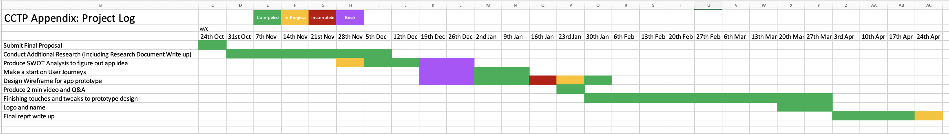

The Gantt chart above is the project log used during this project.

**Appendix B: Project Timeline**

|  |  |  |
| --- | --- | --- |
| October | Final proposal to be submitted by (25/10/22) | 7 days |
| November | Conduct research for research documentation (13/12/22)  Figure out app feature ideas (SWOT analysis, competitor research)  Make a start on user journeys, paper prototypes and wireframes for demo (w/c 23/01/23) | 20 days  10 days  10 days |
| December | Start to write up more detailed research report (13/12/22)  Finalise first app prototype video demo | 10 days  5 days |
| January | Hand in demo (w/c 23/01/23)  Make a start on final report | 1 day  20 days |
| February | Work on final report  Work on app prototype (finalise design process, persona, user journey map etc) | 15 days  15 days |
| March | Work towards finishing up report  Finalise prototype  Record 2 – min video of prototype | 15 days  7 days  1 day |
| April | Work towards hand-in artefact file, report (7000 words) and 2 min video demo of prototype (25/04/23)  Submission (25/04/23)  Prepare for viva (w/c 15/05/23) | 25 days  1 day  10 days |
| May | Viva | 1 day |

Above is the project timeline that was creatred at the start of the project. This layed out a brief guideline follow when completing the project.

**Appendix C: Assets used in the Project** (not included in word count)

This is a list of project assets: all source materials used in the project. Clearly state which were produced by yourself and which were not. If not produced by yourself, include their reference, and status with regard to copyright/ creative commons licensing.

**Front Cover**

Front cover: All assests shown in front cover were created from scratch by Ryan Brereton. App status bar at top of phone screen: Preset template obtainable from Apple Developer Design site. [<https://developer.apple.com/design/resources/#ios-apps>]

**App Prototype**

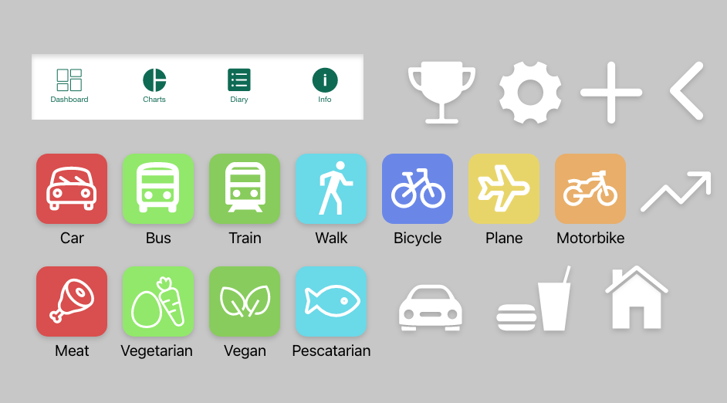

All Icons shown are from a plugin installed into Adobe Xd called Icons 4 Design. [<http://emsoftware.com/xdplugins/icons-4-design/>]

**Appendix D**

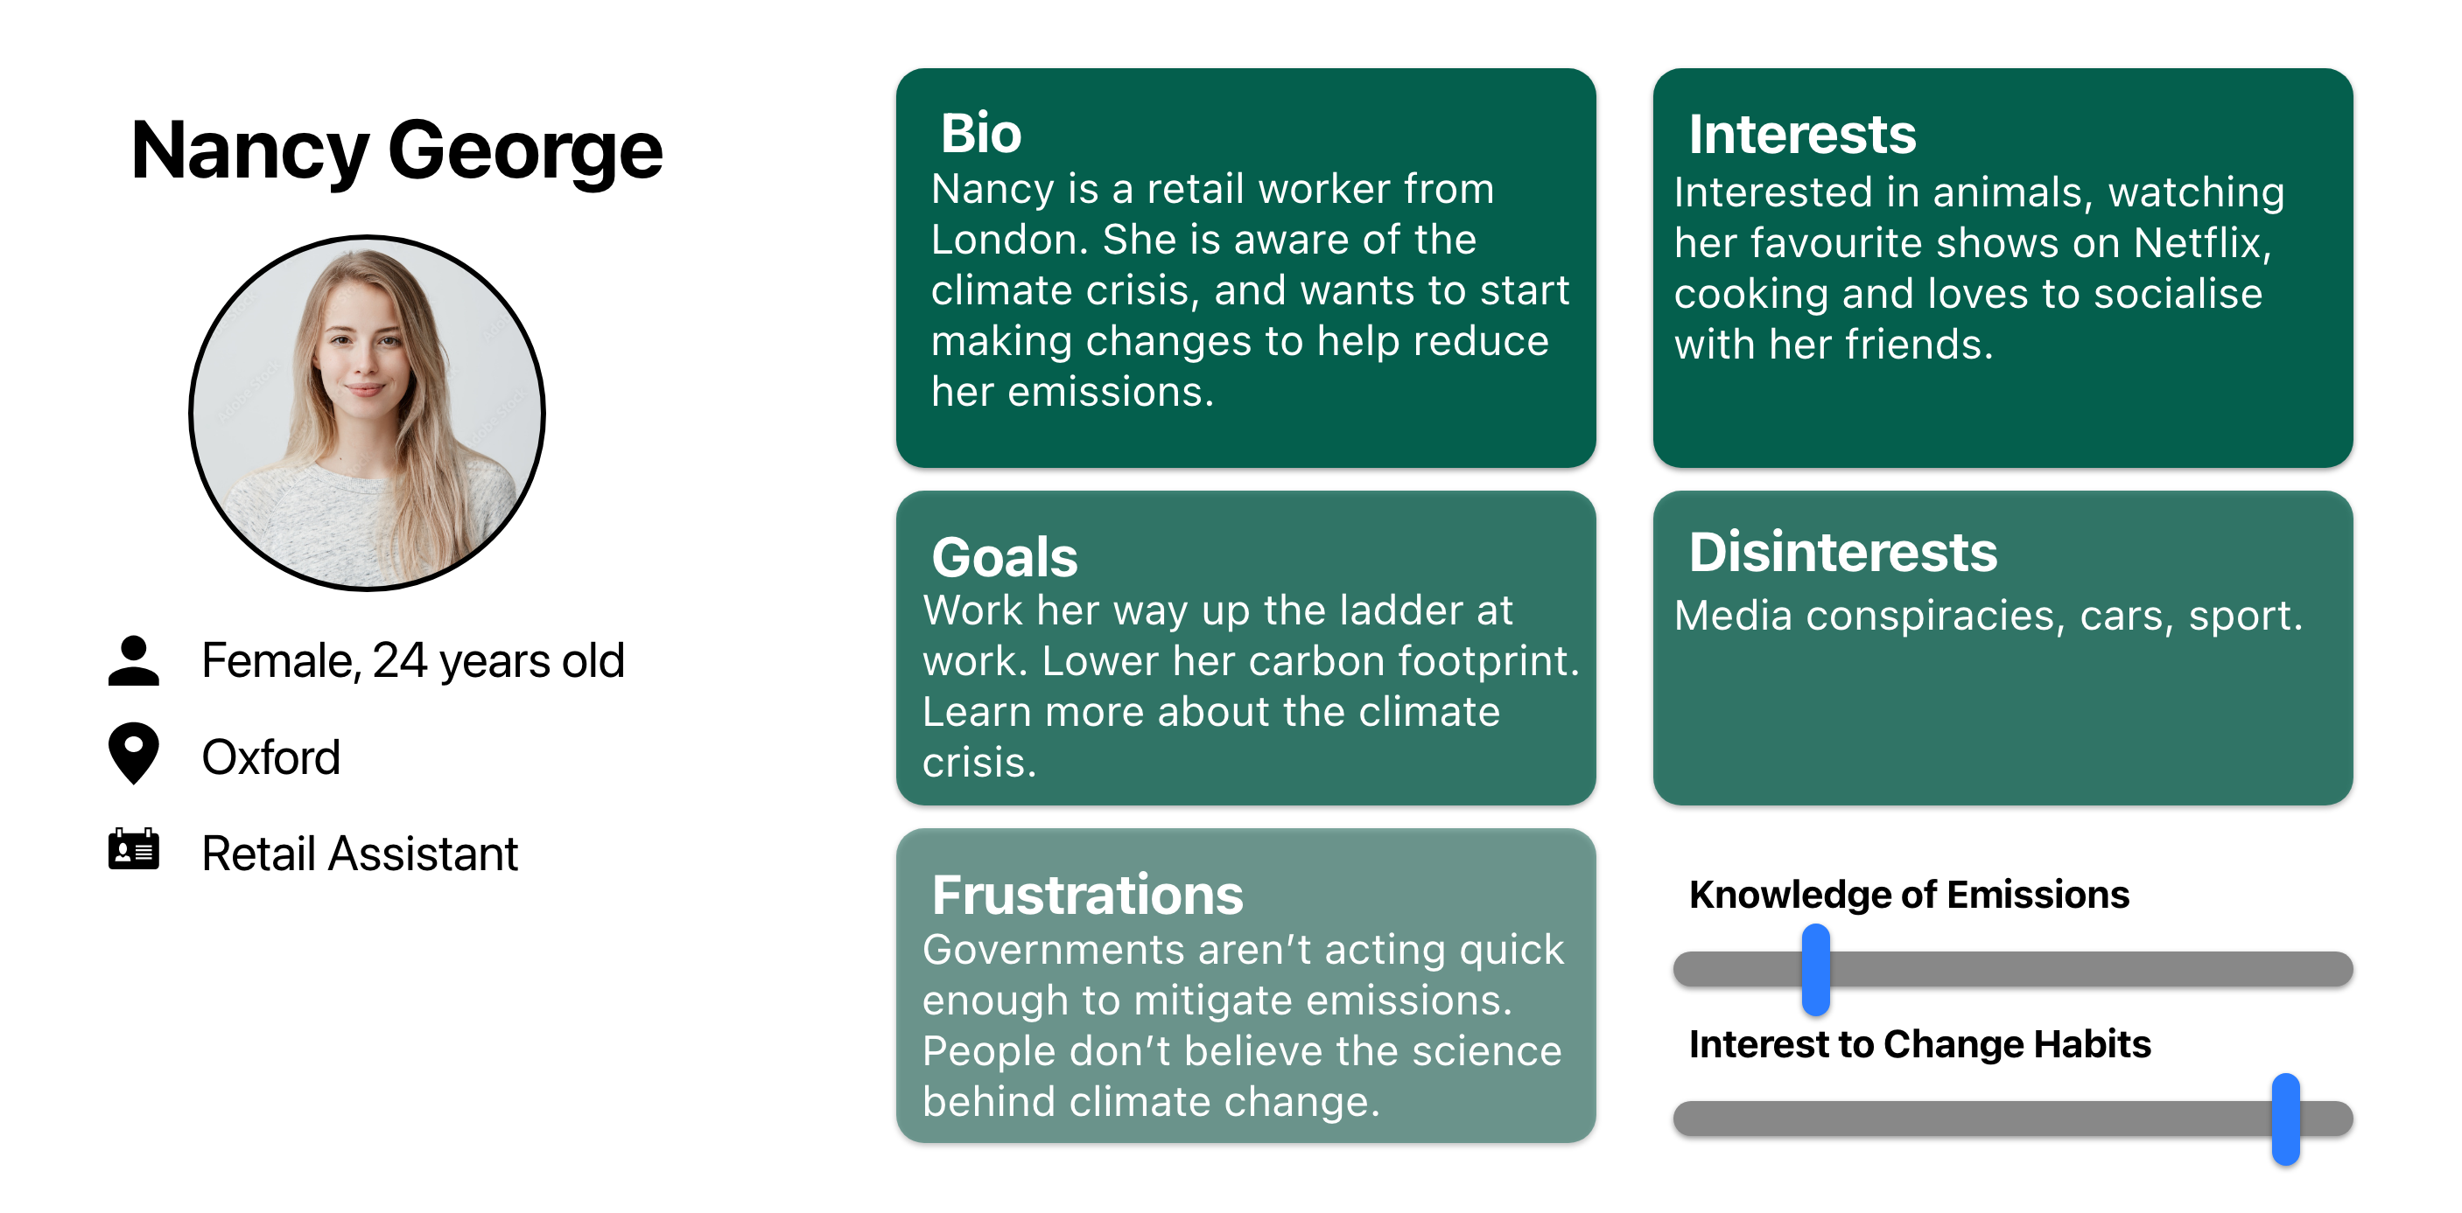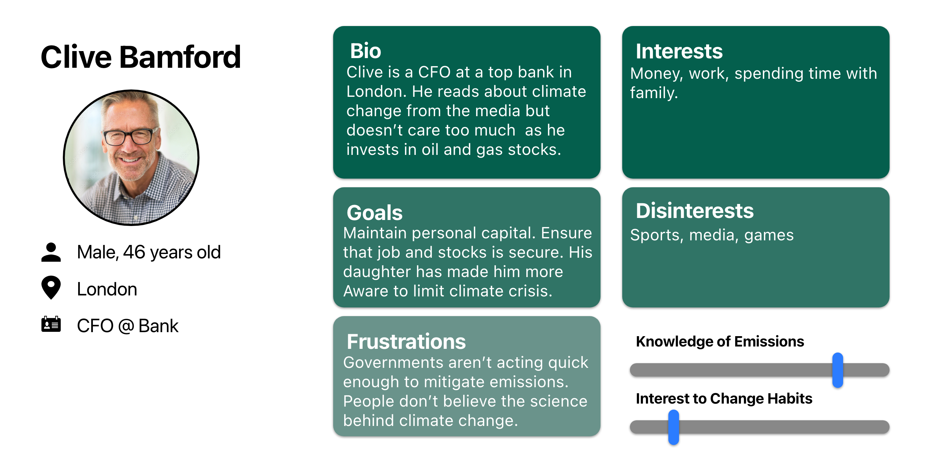

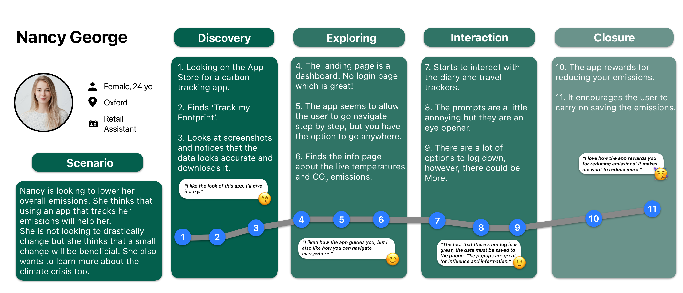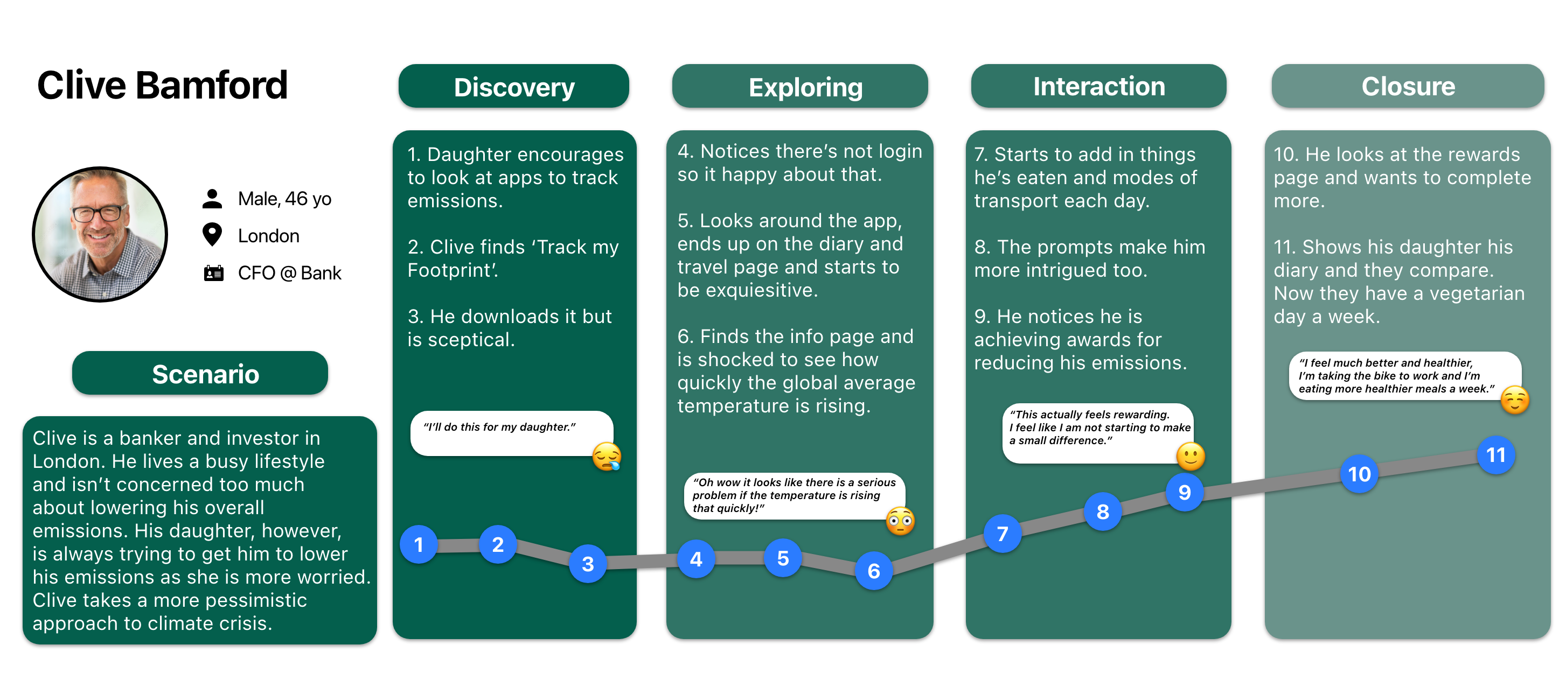

The images above are the user persona journeys created for this project. Each persona and journey is an ideal demographic and use case for the app if it were to be developed. Each persona and user journey symbolises the ideal demographic and use case for the app.

**Appendix E**

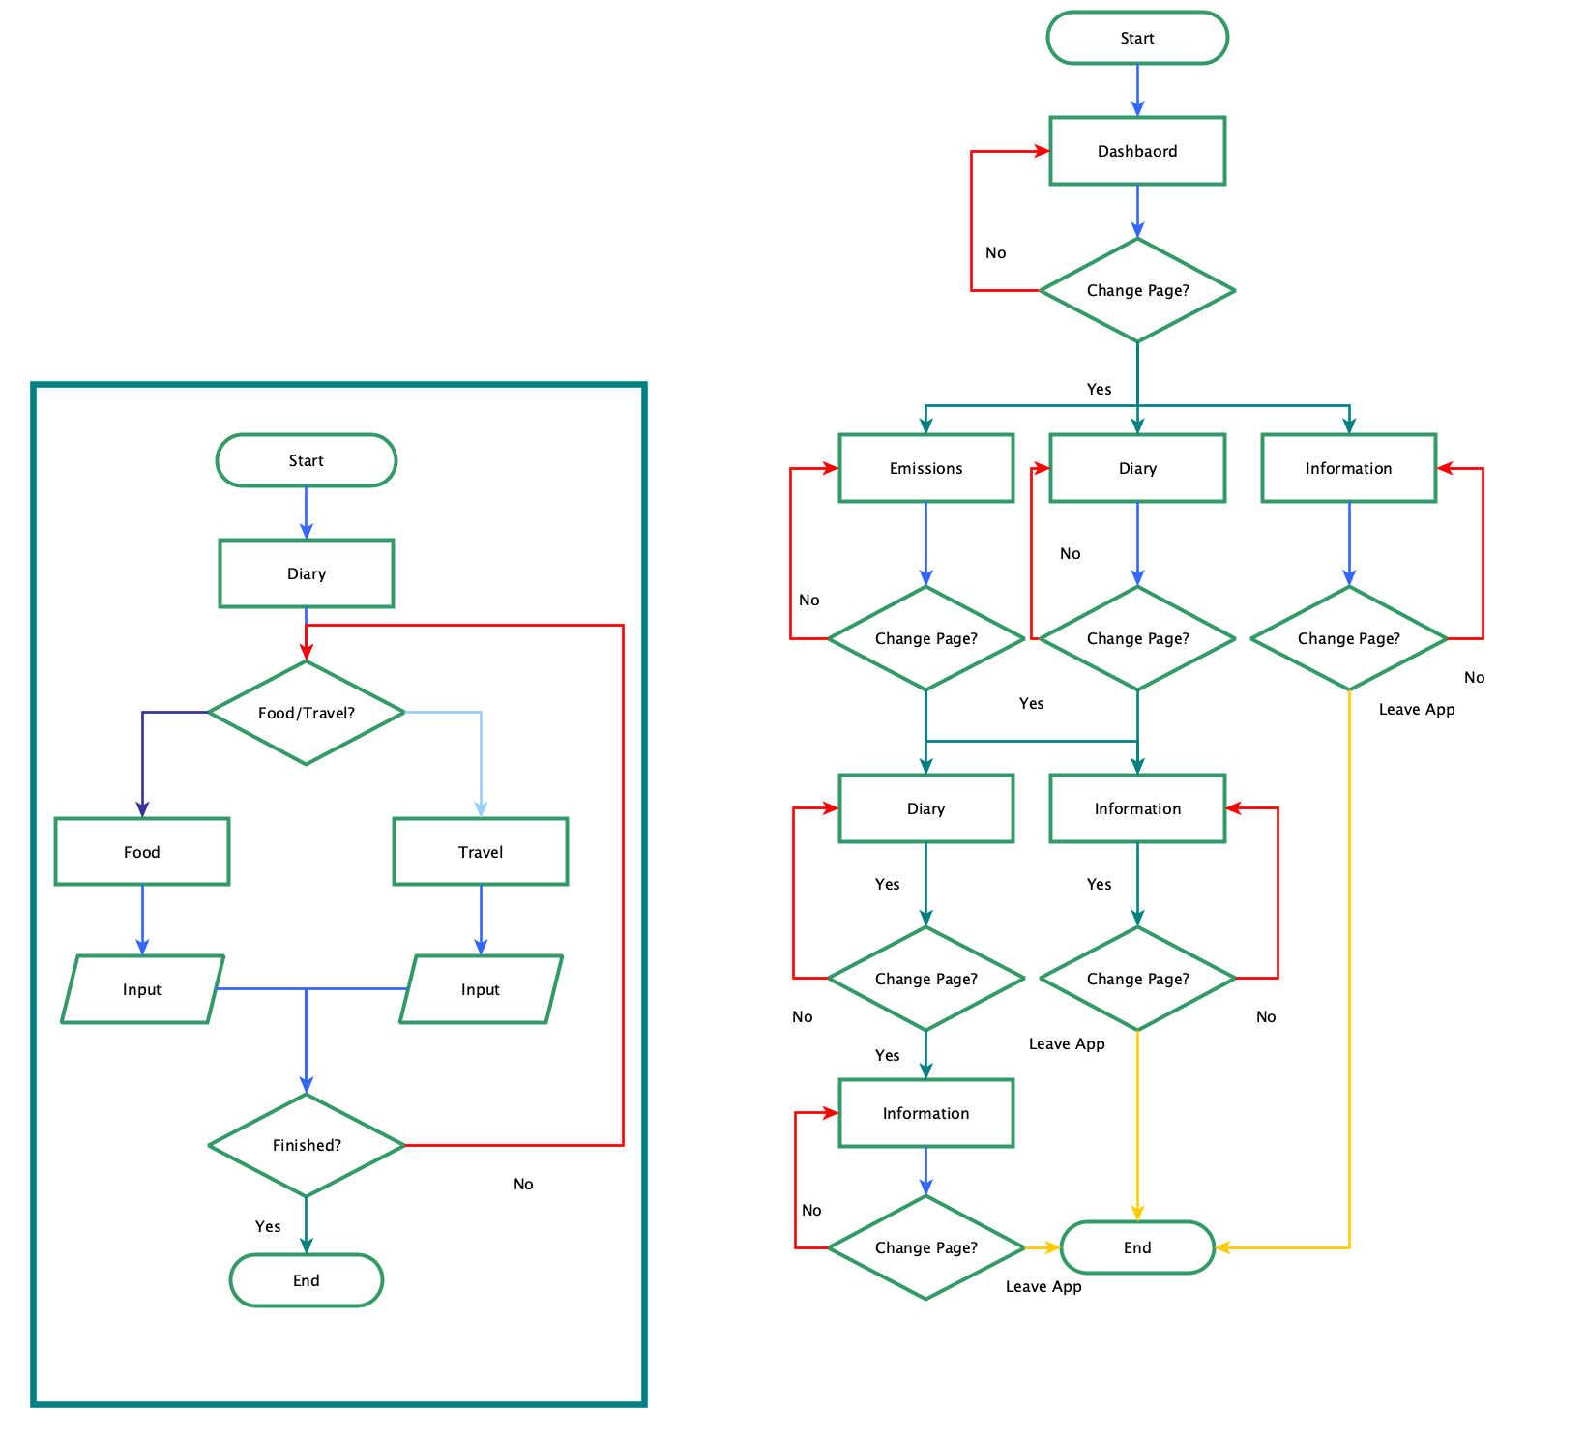

This is a flow chart visualising the navigation of the prototype.